# **Wellness Translated, Level A Indicators**

Objective Definitions.

Management of methylene bridges, methylene bridge cysteines in particular, and assurance of PEMT catalytic function to prevent disease, detrimental behavior, chronic disease, detrimental aspects of aging, while also assuring plasticity in repair, stabilization, and anatomical regeneration as well as optimizing pioneering anatomical development programs. A priority is afforded to managing methylene bridges of phosphatidylethanolamine, their direction toward autophagy anchoring as glyceryl versions, their direction through exclusion from PEMT third methylation toward antihistamine function and recycling when glycosylated, as well as their preferred selection by PEMT when lightly glycosylated or unglycosylated. PEMT1, PEMT2 and PEMT3 direct a portion or fraction molecular, metabolic, chemical, polymerization potential, and structural translation of these toward packing and storage as enriched versions of phosphatidylcholine using phosphatidylethanolamine as substrate for its catalytic production enriched resolution phase fatty acid exhibiting phosphatidylcholine, The energy, polymerization and structural multiplicity is derived from eV-, electrons or hydride from the systems and influences of the Universes.

Each of the categories here exhibit approved, approval process involved, natural, nutraceutical or food derived molecules that can inhibit, modulate or upregulate a pathway, enzyme, protein or physiological function. Search of the following website using key words should provide numerous instances of these therapeutics along with their status as natural or approved pharmaceuticals.

Certificate of Need Health Resources Planning Areas are mentioned to counteract roemer's dynamics, stabilize Certificate of Need Health Resources Planning, and support Narrow Networks which counteract roemer's dynamics, utilizing systems and social institutions in a wider context, particular through shared Human outcomes optimization assurance priorities. Services performed in health Resources Planning Areas and Certificate of Need Health Resources Planning Areas to abate and counteract any other than beneficial correlations when increase in health resources or increase in health facility resources occurs including changes in ratios of health resources when compared to population levels.

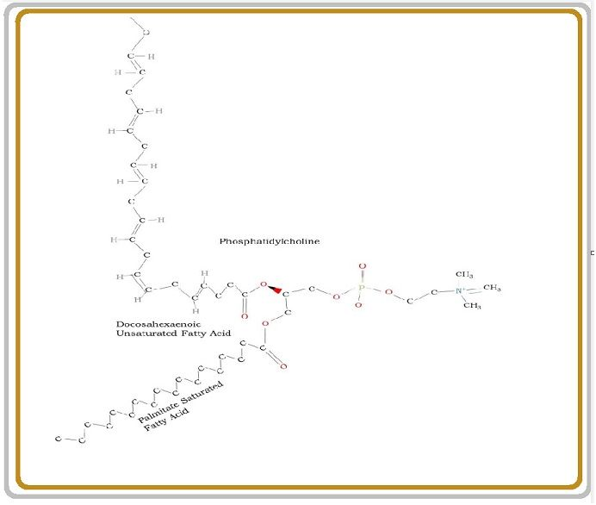

**Precise Care Matrix, Wellness Translated**

## Managing methylene bridge cysteine or the clinical indicator eHCY or elevated homocysteine

## Elevated methylene bridge cysteine or elevated homocysteine recommended to be managed toward 3.7 um/L may be optimal. Above 6 or 7 um/L risk increases 99.995% requirement at least managed therapy. 10 um/L or higher requires inpatient therapy if accompanied by symptoms and outpatient/office therapy if not accompanied by systems. 15 um/L or higher require inpatient therapy. Methylene bridge cysteine treatment toward 3.7 um/L should be a priority in medical, physiological, regenerative, behavioral, emergency, acute, subacute, inpatient, outpatient, office, home, allopathic, traditional, Eastern and Wholistic care.

1. Elevated HCY, clinical indicator HCY or eHCY, methylene bridge cysteine
   1. Bystolic or Nebivolol. Saline. NMDA Receptor inhibitors
   2. Phosphatidylcholine, Choline, Alpha-GPC, Choline Kinase alpha inhibitor Pregnenolone, DHEA, S - Methylmethionine sulfonium, Methylsulfonylmethane, A complete mineral supplements, minerals from pink Himalayan sea salt, a complete natural vitamin supplement with B12/B6/thiamine/pantothenic acid/K2/Biotin, Riboflavin, other vitamins. Glutathione. Catalase. Selenium. Sulfobetaine. Superoxide Dismutase. N Acetyl L Cysteine. Peroxiredoxin-6. Cysteine. Histidine. Cystathionine.
2. Transsulfuration Pathway Depletion of methylene bridges to nonmethylene bridge cysteine.
   1. This suggests that sulfur should be added to B6, Methionine, NAD+, Serine, Danshen/Red Sage/Salvia M, Propionate, Succinate.
   2. Metabolites Cystathionine, Cysteine, Alpha-Ketobutyrate, CoA, Glutathione, and simple Sulfates such as H2S or HS, and Cystine.
3. Managing Homocysteic Acid, Derivative of Homocysteine
   1. Saline along with Alkalinization Therapy.
   2. Vitamin K1 and Vitamin K2 as Menaquione-4.
   3. NMDA Receptor inhibitors
4. Managing methylene bridge Thiolactone, Derivative of methylene bridge cysteine
   1. However, PON1 by a number of factors.
   2. PON1 Translocation through SREBP2 and SP1 integration at the PON1 promoter occurs resultant of Statin, Quercetin and Glucose.
   3. PON1 activation through the aryl hydrocarbon receptor occurs resultant of Quercetin, Resveratrol and Aspirin utilization.
   4. Berberine, however, induces PON1 through the JNK-c-JUN signaling pathway. Resveratrol is a phytoalexin. trans 3,4,5,4′-tetramethoxystilbene
   5. Pomegranate juice polyphenolics stimulate PON1 expression through the PPARy-PKA-cAMP signaling pathway.
   6. Unknown mechanisms of action enable PON1 upregulation resultant of utilizing Curcumin, Betanin, Isothiocyanates, Licorice Polyphenolics, and olive oil.
5. BHMT Pathway for decreasing methylene bridge cysteine through recycling into Methionine
   1. Glutathione. Trimethylglycine. 6s 5678 Tetrahydrofolate, Zinc. N Acetyl-L Cysteine, Peroxiredoxin.
6. BHMT2 Pathway methylene bridge cysteine through recycling into Methionine
   1. Glutathione. S-Methylmethionine (S – Methylmethionine Sulfonium). 6s 5678 Tetrahydrofolate, Zinc. N Acetyl-L Cysteine, Peroxiredoxin.
7. Thetin-methylene bridge cysteine Pathways decreasing Homocysteine through recycling into Methionine
   1. Dimethylthetin, Trimethylsulfonium, dimethylsulfonioacetate, ethylmethylthetin, dimethyl-alpha-propiothetin, dimethyl-beta-propiothetin, ethyl methyl-beta-propiothetin, dimethyl-gamma-butyrothetin, methionine, methylsulfonium, trimethylsulfonium, ethyldimethylsulfonium, butyldimethylsulfonium.
8. Thiopurine/Thioether S – Methyltransferase
   1. S-Adenosyl homocysteine, H+, and 6 methylthiopurine.
   2. 6 – methyl thioguanine, H+ and S -adenosyl L homocysteine.
   3. S -adenosyl L homocysteine and a thiopurine s – methylether
9. Methionine Synthase
   1. 5, Methyltetrahydrofolate, Vitamin B12 Methylcobalamin
10. Trimethylsulfonium Tetrahydrofolate N Methyltransferase
    1. Trimethylsulfonium and 6s 5678 Tetrahydrofolate bidirectionally potentiates dimethylsulfide and 5 methyltetrahydrofolate
11. S-adenosyl Methionine Synthetase
    1. Methionine, Water and ATP, potentiate phosphate, diphosphate and S-Adenosyl Methionine.
12. MARS1/MARS2 Methionyl – tRNA – Methionyl Ligase
    1. Methionine is important because it is a starting factor or primer in synthesis of more than 99.5 percent of gene transcription products. MARS1, for instance, as Methionine tRNA Ligase catalyzes synthesis of AMP, diphosphate, L-methionyl tRNAMet from ATP, L – methionine and tRNAMet. MARS1 occurs in the Nucleus of Homo Sapiens and MARS2 occurs in the mitochondria, performing a role in enabling incipient nuances of synthesis of RNA in Ribosomal Molecular Machines.
13. S-adenosyl methylene bridge cysteine Hydrolase, SAH, SAHH
    1. NAD+ availability, compared to NADH, potentiates production of Homocysteine from S-Adenosyl Homocysteine.
14. INMT, Indolethylamine N – Methyltransferase, Thioether S - Methyltransferase
    1. Dimethyl Sulfide, Trimethylsulfonium, a primary methylated amine, a secondary methylated amine. 2-methylthioethanol, Dimethyl Selenide, Dimethyl Telluride, Diethylsulfide, Tryptamine, Diethylsulfide, all along with H+. Increased levels of S-Adenosyl Methionine can naturally potentiate this enzyme toward S-Adenosyl Methionine, but the trimethylated versions of these substrate are exclusive in catalyzing activity toward S –Adenosyl Methionine. Trimethylsulfonium, Trimethylselenonium, Trimethyltellurium , and possibly Trimethylglycine, although Trimethylglycine can be used by BHMT to produce Methionine and Dimethylglycine. Trimethylsulfonium produces linear graphs of the depletion of S-Adenosyl Homocysteine because it is used by TTMT toward 6s 5678 Tetrahydrofolate/Dimethylsulfide, used toward Thioglycolic Acid/Methionine by Thetin – methylene bridge cysteine Methylpherase, and used toward S-Adenosyl Methionine/Dimethyl Sulfide.